**TITLE OF LAB: (INTRODUCTIONS TO POINTERS AND ARRAYS)**

**LAB REPORT NO.01**



**Spring 2022**

**CSE-210L Data Structures and Algorithm Lab**

Submitted by

Name: **Safi Ullah Khan**

Registration No. **20PWCSE1943**

Class Section: **B**

“On my honor, as student of University of Engineering and Technology, I have neither given nor received unauthorized assistance on this academic work.”

Student Signature: ______________

Submitted to:

**Dr. Khurram Shehzad Khattak**

(Friday, July 29th, 2022)

**Department of Computer Systems Engineering**

**University of Engineering and Technology, Peshawar**

**OBJECTIVES OF THE LAB**

‐‐‐‐‐‐‐‐‐‐‐‐‐‐‐‐‐‐‐‐‐‐‐‐‐‐‐‐‐‐‐‐‐‐‐‐‐‐‐‐‐‐‐‐‐‐‐‐‐‐‐‐‐‐‐‐‐‐‐‐‐‐‐‐‐‐‐‐‐‐‐‐‐‐‐

In this lab, we will learn about the relation between arrays and pointers, and use them efficiently in our program.

* Pointers and dynamic memory allocation
* Arrays
* Connection between arrays and pointers

‐‐‐‐‐‐‐‐‐‐‐‐‐‐‐‐‐‐‐‐‐‐‐‐‐‐‐‐‐‐‐‐‐‐‐‐‐‐‐‐‐‐‐‐‐‐‐‐‐‐‐‐‐‐‐‐‐‐‐‐‐‐‐‐‐‐‐‐‐‐‐‐‐‐‐

## **Task 01**

Write a program that reads numbers from the user in to an array of type “float”, average them and print the result.

**Screenshot of Input:**

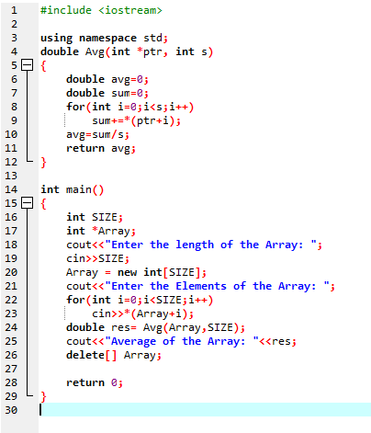

**Screenshot of Output:**

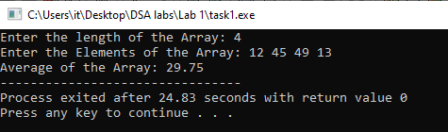

## **Task 02**

Write a function that takes an int array and array’s size as argument and return maximum value of array elements.

**Screenshot of Input:**

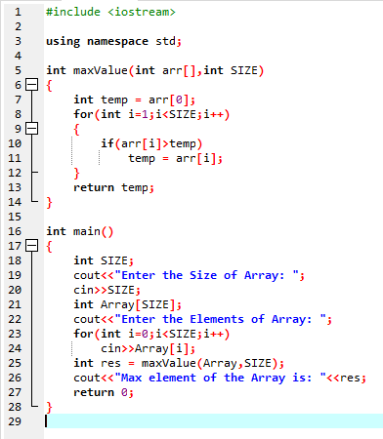

**Screenshot of Output:**

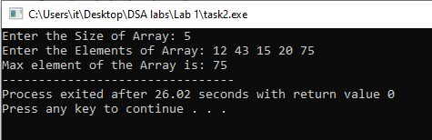

## **Task 03**

Write a function that takes an int array and the array's size as arguments. It should create a new array that is twice the size of the argument array. The function should copy the contents of the argument array to the new array, and initialize the unused elements of new array with -1. The function should return a pointer to the new array.

**Screenshot of Input:**

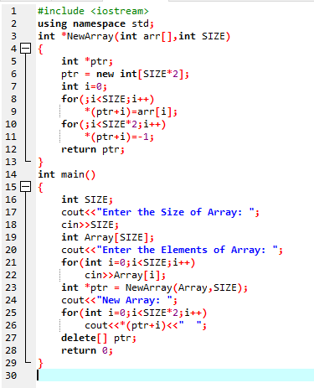

**Screenshot of Output:**

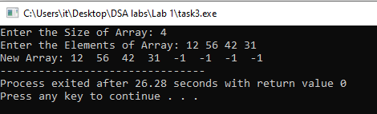

## **Task 04**

Write a function that takes two int arrays and the arrays' sizes as arguments. It should create a new array big enough to store both arrays. Then it should copy the contents of the first array to the new array, and then copy the contents of the second array to the new array in the remaining elements, and return a pointer to the new array.

**Screenshot of Input:**

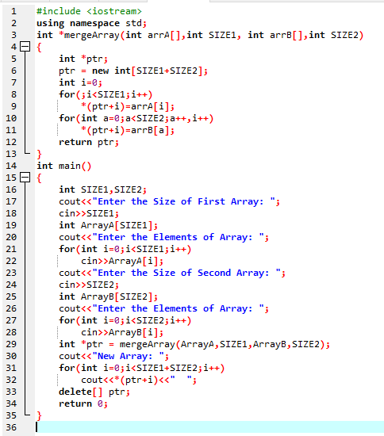

**Screenshot of Output:**

